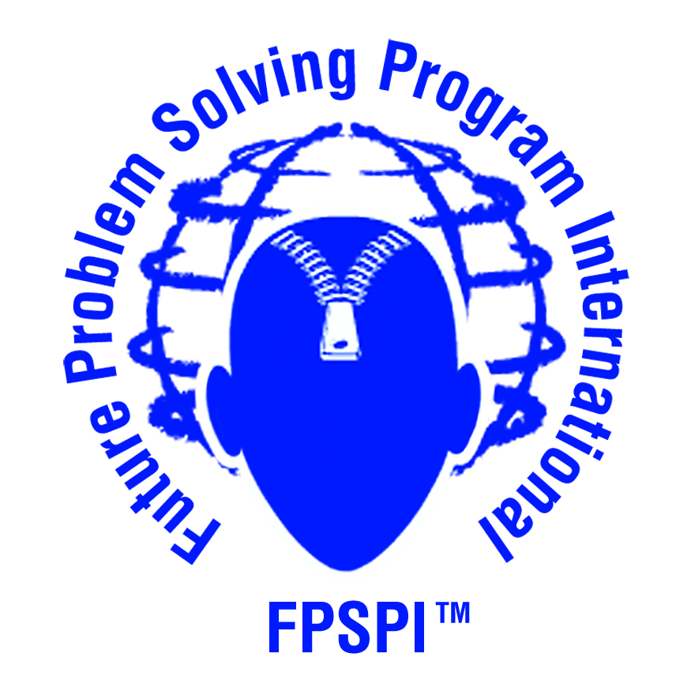
FUTURE PROBLEM SOLVING PROGRAM INTERNATIONAL
2012-2013 INDIVIDUAL REGISTRATION FORM
GLOBAL ISSUES PROBLEM SOLVING
NC Future Problem Solving Program

North Carolina Future Problem Solving

Submit one form for each coach. Register only one school per form.

School and Home Information
Coach & School
Coach |  |  | School |  |  |  |  | County
Mailing Address for evaluated booklets:
 |  | Street Address
 | City |  |  | State |  |  | Zip Code
School Phone: | ( ) |  | Home Phone: |  | ( )
Coach’s home
E-mail:
School E-mail if Teacher Coach:
Coach’s home address
 | Street Address
 | City: |  |  | State |  |  | Zip Code:
School Address (if different from mailing address)
 | Street Address
 | City |  |  | State |  | Zip Code

Division (Indicate number of teams [up to four students per team] you are registering in each division):
Junior Individual | (Grades 4-6)  2012-13 GPS TOPICS  PP#1 CULTURE OF CELEBRITY  PP#2 ROBOTIC AGE  QP MEGACITIES  SB OCEAN SOUP  INTERNATIONAL TOPIC will be announced in February
Middle Individual | (Grades 7-9)
Senior Individual | (Grades 10-12)
TOTAL # OF INDIVIDUALS:
TOTAL COST @ $50 per INDIVIDUAL | $
Registration for new teams closes February 2, 2013

Complete this form and e-mail to NC FPS Affiliate Director

E-mail this form to sandyhortonFPS@bellsouth.net WEBSITE: www.nc-fps.org
Make registration checks out to NC FPS and mail to the following address:
Sandy Horton, Affiliate Director, NC FPS
8133 NC 181
Newland, NC 28657

