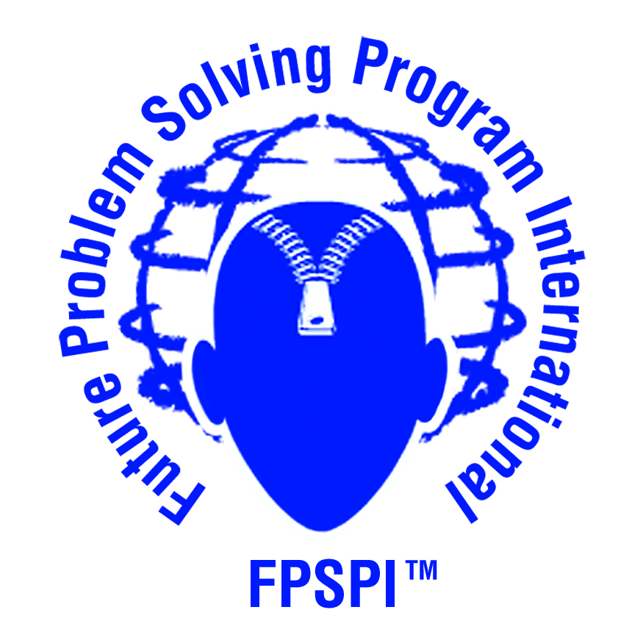
North Carolina Future Problem Solving

Submit one form for each coach. Register only one school per form.
FUTURE PROBLEM SOLVING PROGRAM INTERNATIONAL
2012-2013 TEAM REGISTRATION FORM
COMMUNITY PROBLEM SOLVING
NC Future Problem Solving Program

School and Home Information
Coach & School:
 | Coach’s Name |  |  |  | School Name
Info & Evaluation Mailing Address:
Street Address
City |  |  | State |  | Zip Code |  | County
School Phone: | ( ) |  | Home Phone: |  |  | ( )
Coach’s Home
E-mail:
School E-mail for Teacher Coach:
Coach’s
Home Address:
 | Street Address
 | City | State |  | Zip Code
School Address (if different from mailing address
 | Street Address
 | City | State |  | Zip Code

Division (Indicate number of teams [2-15 students per team] you are registering in each division):
Junior team(s) | (Grades 4-6)
Middle team(s) | (Grades 7-9)
Senior Team(s) | (Grades 10-12)
TOTAL # OF TEAMS:
TOTAL COST @ $120 per TEAM | $

Registration for new teams closes February 2, 2013

Complete this form and e-mail to NC FPS Affiliate Director at sandyhortonFPS@bellsouth.net

E-mail this form to sandyhortonFPS@bellsouth.net WEBSITE: www.nc-fps.org
Make registration checks out to NC FPS and mail to the following address:
Sandy Horton, Affiliate Director, NC FPS
8133 NC 181
Newland, NC 28657

